**Soch College of IT**



**Tribhuvan University**

**Institute of Science and Technology**

**Mid-Term Report**

**on**

**Vehicle Number Plate scanning System**

**(VNPSS)**

**Submitted to**

**Department of Computer Science and Information Technology**

**Soch College of IT**

*In partial fulfillment of the requirement for the Bachelor Degree in Computer*

*Science and Information Technology*

**Submitted by**

Nabin Magar(16846/074)

Bibek Acharya(16839/074)

Ganesh Poudel(16844/074)

**feb, 2022**

Contents

1. Introduction 1

2. Background 1

3. Problem of Statement 1

4. MATLAB Vs OpenCV 2

4.1 OPENCV 2

5. Objective 3

6. Literature Review 3

7.Requirement Analysis 3

7.1.Functional and Non-Functional Requirements 3

Functional Requirements: 3

Non-Functional Requirements: 3

8. Design and Implementation 4

8.1 System Design 4

8.2. Flow Chart 4

8.3. Use case diagram 5

8.4. Sequence diagram 6

8.5. Activity Diagram 9

9. Methodology 11

9.1.Phases of Agile Model: 12

9.2. Why we choose agile project? 12

10. Implementation and Testing 13

10.1. System Development Tools 13

10.2. Testing 13

11. Tasks 14

11.1. Tasks Progress 14

11.2. Remaining Tasks 14

12. References 15

# 1. Introduction

This project mainly for police to make them easy to register the vehicle number plate and also for using in the security purposes. The aim is to develop an automatic license plate recognition system to recognize license plate of a vehicle that can be used for traffic management purpose, Identification of stolen cars, Security control of restricted access areas, unattended parking lots etc. The input to the system is a digital image captured by a camera. With the images it acquires, the system will generate report or details of the car on a computer. Once the car number plate is captured it will be processed using image processing techniques. First it extracts the license plate number from an image it then performs character segmentation on the enhanced image and later finds each character from the image and converts it from image format to text format. After the license plate number is recognized, a check is done to monitor, number is stored in the database. If the number is recognized then the barrier will be opened so that the vehicles can enter or else if the vehicle is black listed(unauthorized) then the barrier will remain closed and a message will go to the security personnel informing him that the vehicle arrived at the barrier is an black listed vehicles.

# 2. Background

Vehicle number plate scanning system (VNPSS) contribute to applications such as traffic surveillance, traffic law enforcement, vehicle parking identification, and vehicle access control in a restricted area. Typically, VNPSS system is composed of License plate detection , license plate character segmentation and License plate character recognition.

# 3. Problem of Statement

In context of our country, there has always been a problem in registering the vehicle number plate. people have to stand in a large queue inorder to register their number plate. It is also difficult for the police to register a large number of vehicles as the population is increasing and the demand of the vehicles for daily work is also increasing in large number. It consumes large amount of time to register their number plate.

# 4. MATLAB Vs OpenCV

At present, openCV is a great dealing with the open source library for computer vision and has a large community of users. Open CV has much more functionality to see the computer than MATLAB [2]. Many of their functions are performed on the GPU. The library is updated continuously (a new version is released every 3 to 4 months). In general, the open CV C ++ program can be executed with a high speed than the MATLAB code. Open CV has more functions to see the computer than MATLAB. Many of their functions are performed on the GPU [3]. The C ++ Open CV code is usually run faster than the MATLAB code, but compared to open CV C ++, open CV is much better than C ++. Python is better and easier than other programming languages like C ++ in seeing the computer, we encounter similar options. What a tool you should learn Engineer / Programmer Computer vision – Open CV using C ++, or Open CV using Python, or MATLAB, as at present we have some options to choose from. In the past there were no good libraries to see the computer. We identified these studies by means of relevant books that were available and began coding the special library of special algorithms for computer vision[6]

Like MATLAB, Open CV is also made for image processing and used as an alternative tool and much faster than other simulations. Each function is designed in Open CV, the function structure and data using the image processing coding software. On the other hand we get nearly everything in the world in the form of toolboxes on MATLAB. Although MATLAB is a relatively simple language, this high-level programming language has become slower in some cases. In such cases, open CV works better and produces accurate results. Similarly, it can be very simple to handle some code to model the idea of processing your images. One of the outstanding contributions of the Open Source community in the scientific world is Python.

## 4.1 OPENCV

Open Source Computer Vision Library is a common platform and set of programming functions for real-time applications. The first languages used in C-C ++ are mainly written in C, making them portable to certain platforms such as the digital signal processor. Now the language that is called Python is being used recently, has been developed to encourage adoption by a wider audience. These languages recent versions have interfaces for C ++. Open CV is a multiplatform library, containing C ++, Python, and Java interfaces. Open CV is designed to achieve computational efficiency with a strong focus on real-time applications.

For now; open CV supports many of the improved algorithms for computer vision and automated learning, which are spread daily . Open CV currently supports a vast programming languages such as C ++, Python, Java and others, and is available on different platforms such as Windows, Linux, OS X, Android, iOS, and so on. Here in this system, we used Python as a code language. It is called Open CV Python. We choose the snake because it is easier to understand and more effective. The proposal combines the good qualities in Open CV and Python.

# 5. Objective

The main objective of VPNSS is to recognize the number plate of a vehicles and store in database automatically. This project develops a VNPS system that can detect and capture the vehicle image. With the increase of security risk, capturing and extracting number plate can help to reduce the human error. This project is mainly beneficial for security purpose of vehicles.

Common goals and objectives include the following:

* to recognize the number plate of a vehicles and store in database automatically.
* to use for Security control of restricted access areas, vehicle tracking and monitoring, border crossing, security.
* to reduce excessive time for registration of vehicle number.
* to change the current traditional registration system i.e. handwritten.

# 6. Literature Review

Vehicle Number Plate Scanning System (VNPSS) system in general comprises of three fundamental methods according to Saleem,et. al. [1], G. Balamuruganet. al. [2], and M. V. Srinu, B. S.Shankar [3].

These include vehicle number plate detection, character segmentation, and Optical Character Recognition (OCR). Numerous studies have attempted to explain the methods of an AVNPR system. Many researchers had provided similarly closed methods for this system which consist of few steps for vehicle number plate recognition which are license plate localization, orientation correction, brightness normalization, character segmentation and last but not least, optical character recognition [4]. Something closely similar had been reported by Dhruw & Roy [5] which are the steps to identify and extract the image of the number plate. Then extracting the character, recognize and retrieve the vehicle number plate.

# 7.Requirement Analysis

## 7.1.Functional and Non-Functional Requirements

## Functional Requirements:

* User account form accepts data in validated format.
* Disable additional features if user is not logged in.
* User data must be displayed only if user has logged into his account.
* Check if every login is valid and new accounts are validated.
* User should not be able to create account with the same name.

## 

## Non-Functional Requirements:

* A non-functional requirement tells us about the system’s behavior.
* This also specifies how are the system’s quality characteristics or quality attributes.
* The system is highly reliable.
* Resource consumption is quite low.
* We can add more resources to our project without disturbing the current scenario.

# 8. Design and Implementation

## 8.1 System Design

Systems design is the process of defining the architecture, product design, modules, interfaces, and data for a system to satisfy specified requirements. Systems design could be seen as the application of systems theory to product development.

## 8.2. Flow Chart

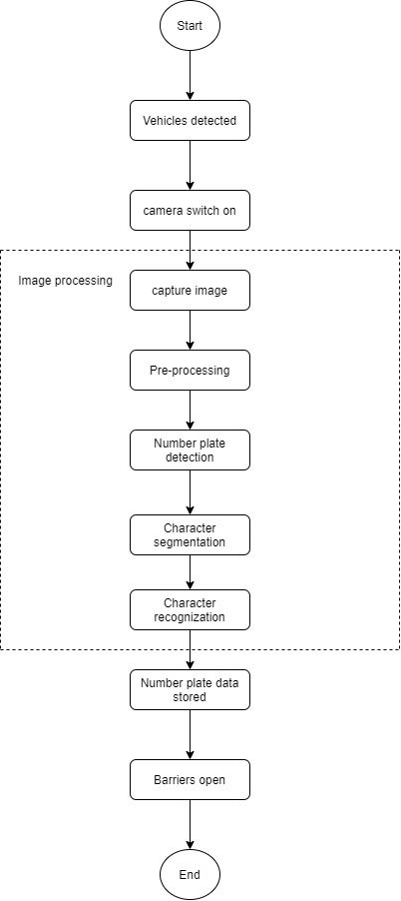

fig(1): Flow chart of VNPSS

## 8.3. Use case diagram

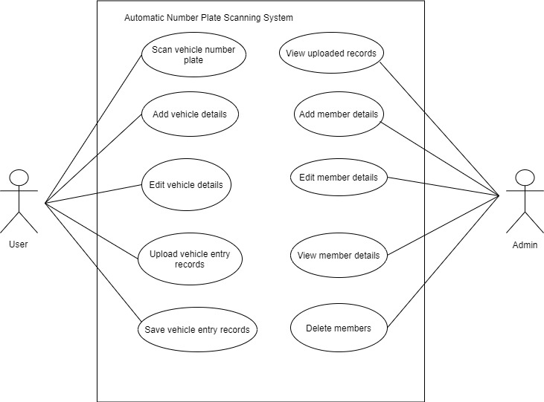

fig(2): Use case Diagram of VNPSS in terms of Admin and user view

## 8.4. Sequence diagram

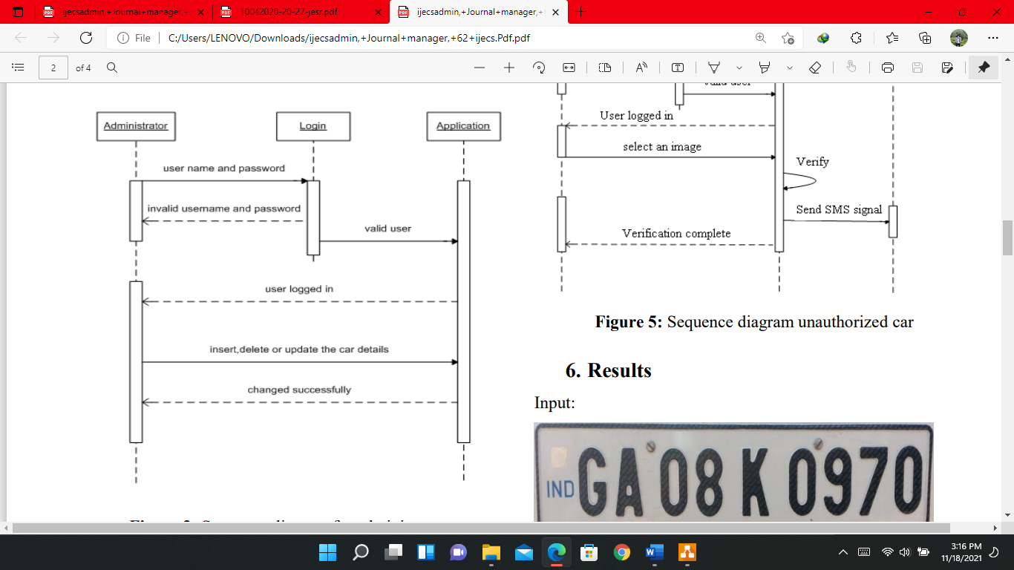

Fig(3): Sequence diagram for administration

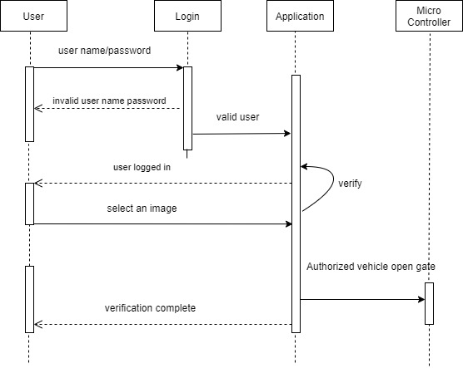

fig(4): Sequence diagram Authorized vehicle

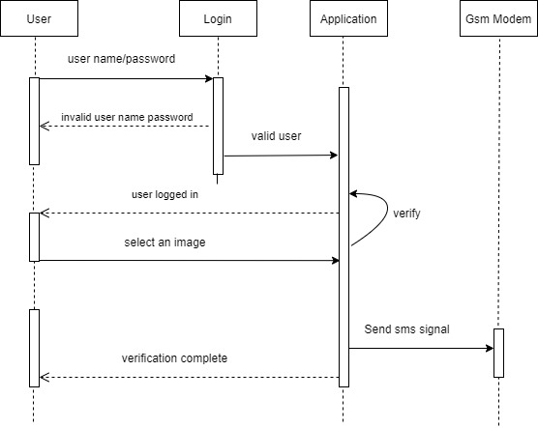

Fig(5): Sequence diagram unauthorized(backlisted) vehicle

## 8.5. Activity Diagram

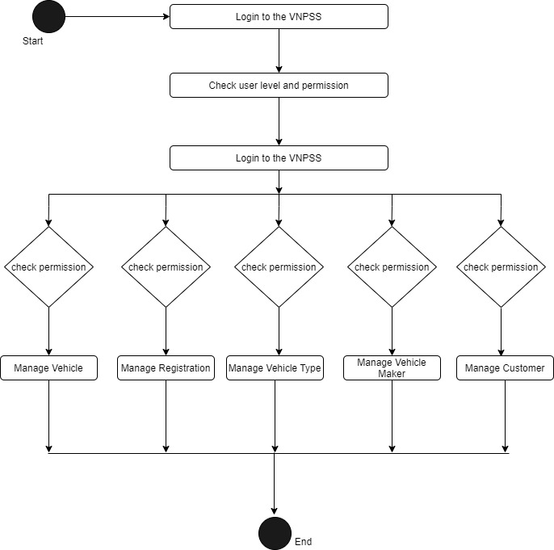

Fig(6): Activity diagram for VNPSS

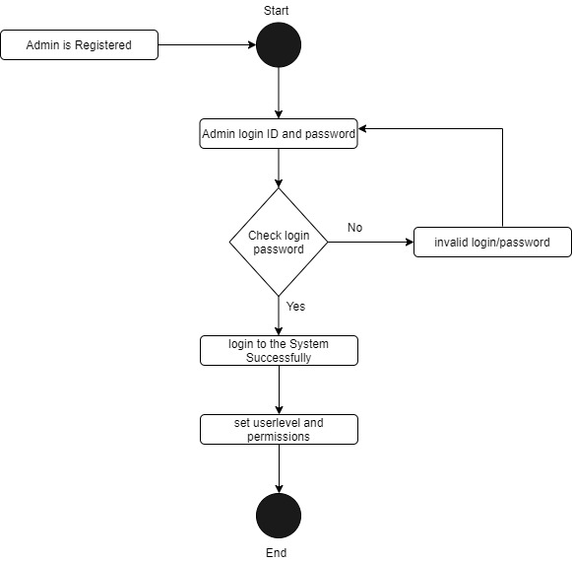

Fig(7): Admin Activity Diagram

# 9. Methodology

The meaning of Agile is swift or versatile. "Agile process model" refers to a software development approach based on iterative development. Agile methods break tasks into smaller iterations, or parts do not directly involve long term planning. The project scope and requirements are laid down at the beginning of the development process. Plans regarding the number of iterations, the duration and the scope of each iteration are clearly defined in advance.

Each iteration is considered as a short time "frame" in the Agile process model, which typically lasts from one to four weeks. The division of the entire project into smaller parts helps to minimize the project risk and to reduce the overall project delivery time requirements. Each iteration involves a team working through a full software development life cycle including planning, requirements analysis, design, coding, and testing before a working product is demonstrated to the client.

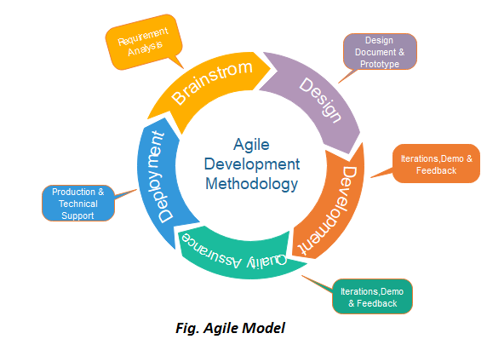

## 9.1.Phases of Agile Model:

Following are the phases in the Agile model are as follows:

* Requirements gathering
* Design the requirements
* Construction/ iteration
* Testing/ Quality assurance
* Deployment
* Feedback

**Requirements gathering:** In this phase, you must define the requirements. You should explain business opportunities and plan the time and effort needed to build the project. Based on this information, you can evaluate technical and economic feasibility.

**Design the requirements:** When you have identified the project, work with stakeholders to define requirements. You can use the user flow diagram or the high-level UML diagram to show the work of new features and show how it will apply to your existing system.

**Construction/ iteration:** When the team defines the requirements, the work begins. Designers and developers start working on their project, which aims to deploy a working product. The product will undergo various stages of improvement, so it includes simple, minimal functionality.

**Testing:** In this phase, the Quality Assurance team examines the product's performance and looks for the bug.

**Deployment:** In this phase, the team issues a product for the user's work environment.

**Feedback:** After releasing the product, the last step is feedback. In this, the team receives feedback about the product and works through the feedback.

## 9.2. Why we choose agile project?

We choose agile project because of the following reason:

* Lower Cost
* Providing teams with a competitive advantage by catching defects and making changes throughout the development process, instead of at the end.
* Speeds up time spent on evaluations since each evaluation is only on a small part of the whole project.
* Ensures changes can be made quicker and throughout the development process by having consistent evaluations to assess the product with the expected outcomes requested.
* Encourages open communication among team members, and clients.

# 10. Implementation and Testing

## 10.1. System Development Tools

The packages or library used in development of Vehicle Number Plate Scanning System (VNPSS) are:

1. OpenCV Python
2. Python-tesseract

1. OpenCV Python

OpenCV is an open source computer vision library. The library has more than 2500 optimized algorithms. These algorithms are often to search and recognize faces, identify objects, recognize scenery and generate markers to overlay images using augmented reality, etc.

Installation: $ pip install opencv-python

2. Python-tesseract

Py-tesseract is an optical character recognition (OCR) tool for python. That is, it’ll recognize and “read” the text embedded in images. Python-tesseract is a wrapper for Google’s Tesseract-OCR Engine. It is also used as an individual script, because it can read all image types like jpeg, png, gif, bmp, tiff, etc. Additionally, if used as a script, Python-tesseract will print the recognized text rather than writing it to a file. It has ability to recognize more than 100 languages.

Installation: $ sudo apt-get install tesseract-ocr-eng

## 10.2. Testing

The software has been tested for many vehicle images. One of the figure of the image is shown in figure below. It consists vehicle image, its correct number plate, number read by our system and the result is successful.

Example:

Input:

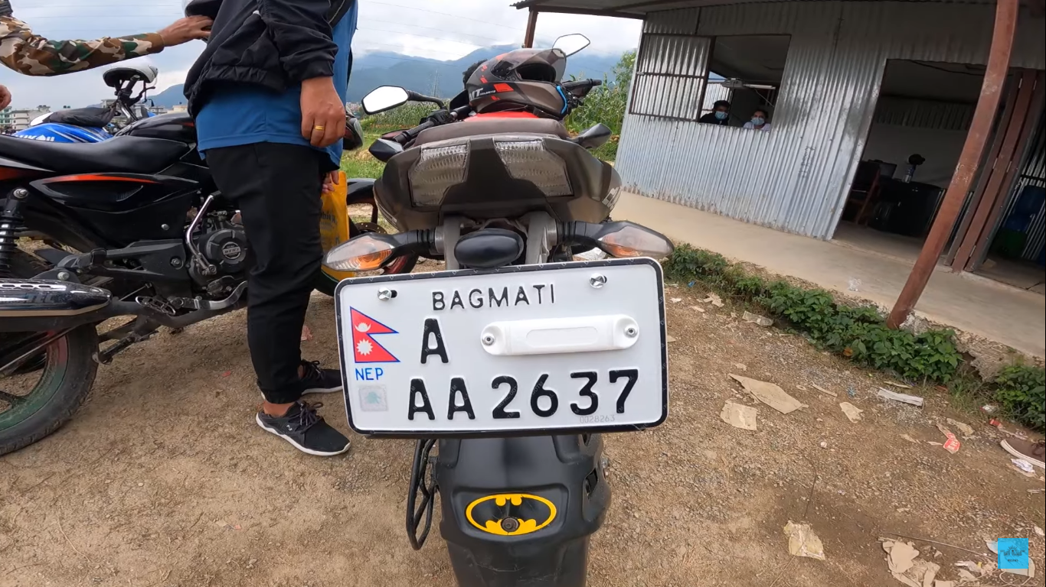

Output: AA2637

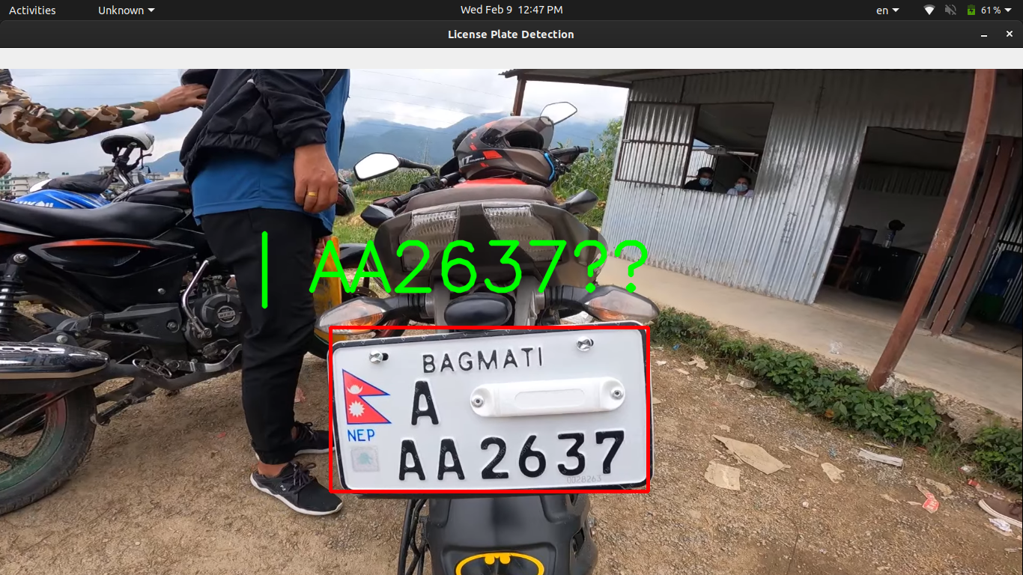

**Approach:**

* Find all the contours in the image.
* Find the bounding rectangle of every contour.
* Compare and validate the sides ratio and area of every bounding rectangle with an average license plate.
* Apply image segmentation in the image inside validated contour to find characters in it.
* Recognize characters using an OCR.

Methodology:

1. First of all we convert it into the grayscale.

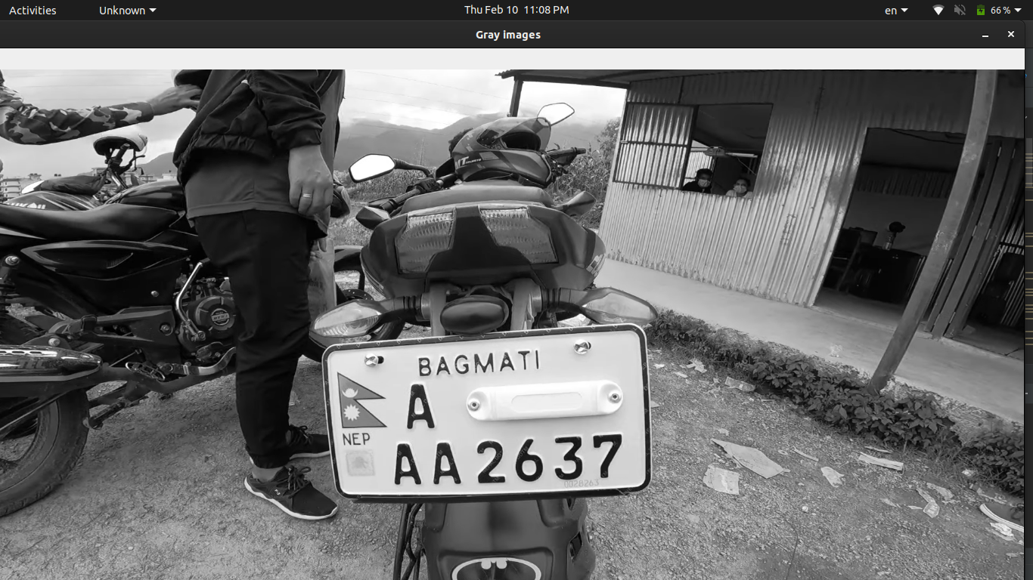

1. Find vertical edges in the image.

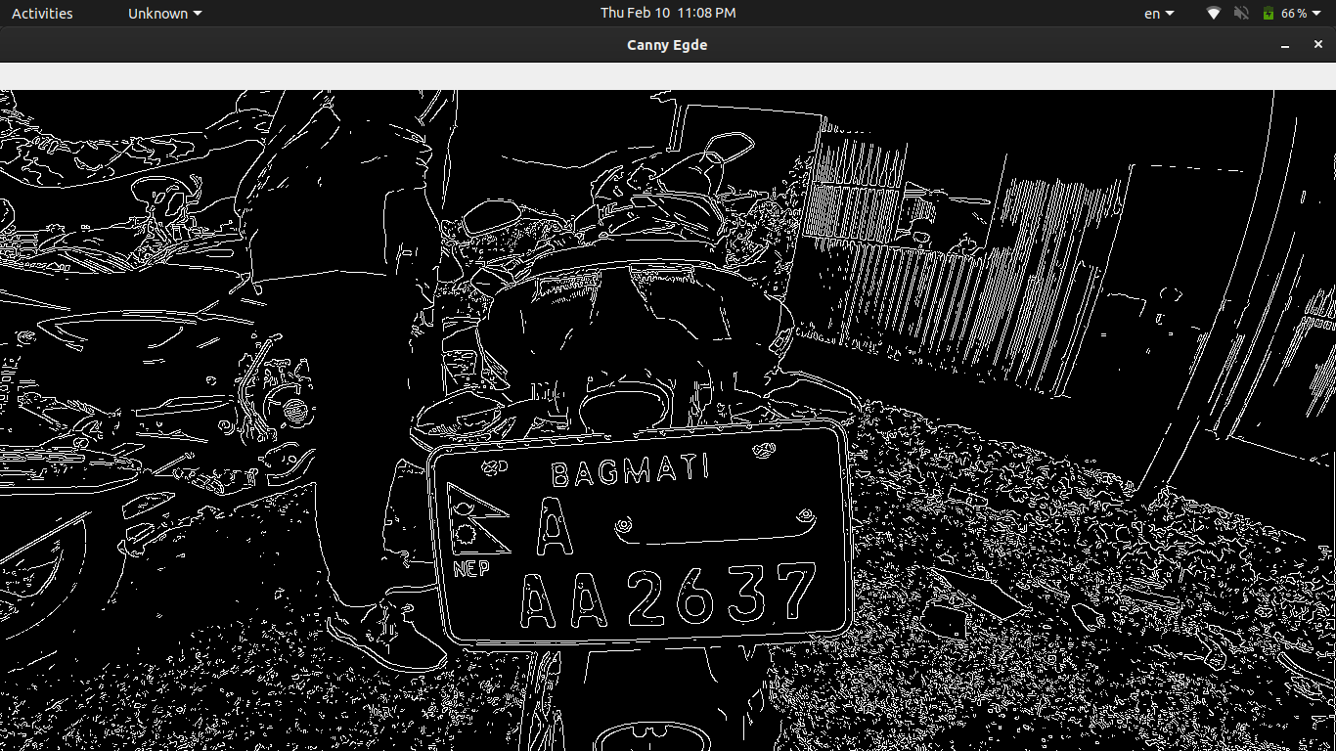

1. find contours based on edges.
2. Initialize license plate contours and x,y coordinates.
3. Find the contour with 4 potential corners and create ROI around it.
4. Removing Noise from the detected image, before sending to tesseract

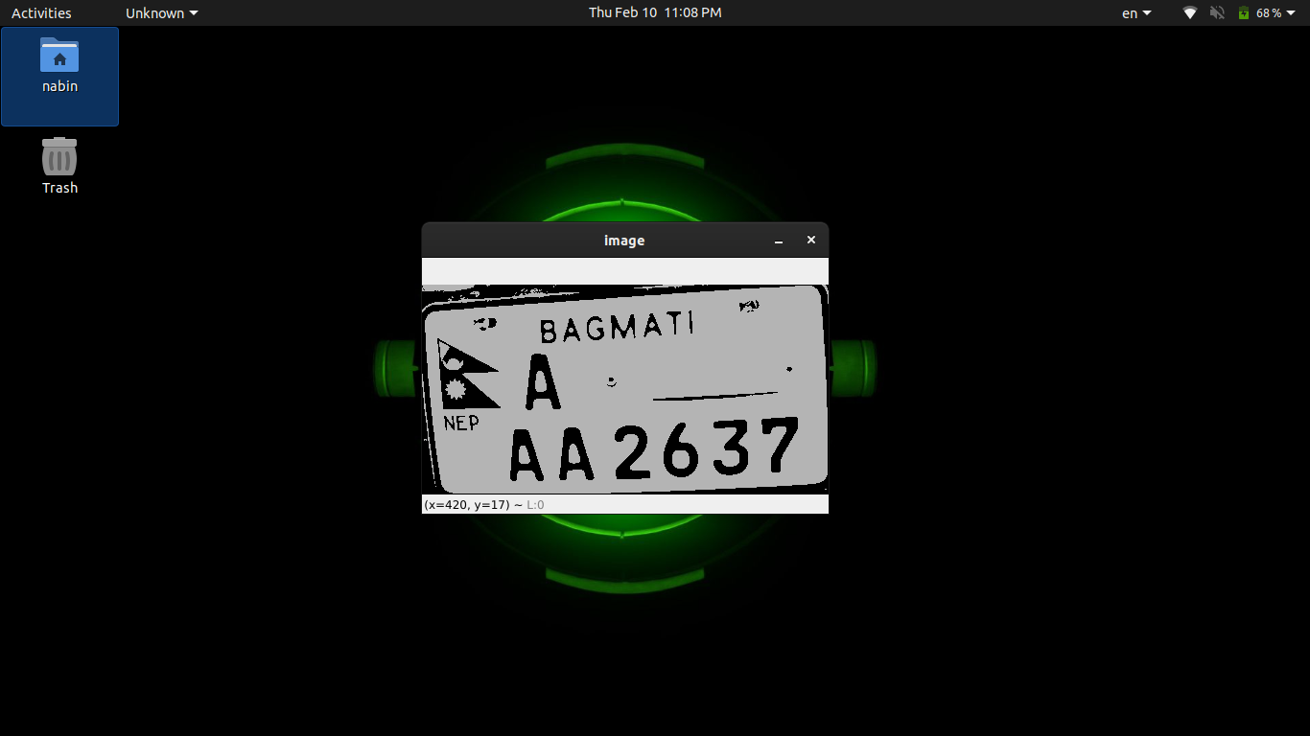

1. Text recognition
2. Draw license plate and write the text

# 11. Tasks

## 11.1. Tasks Progress

Fig: Task progress

## 11.2. Remaining Tasks

1. UI/UX
2. Database connection

* UI UX
* Database
* Error Finding

# 12. References

[1] Saleem, N., Muazzam, H., Tahir, H. M., &Farooq, U.(2016). Automatic license plate recognition using extracted features.4th .IEEEInternational Symposium on Computational and Business Intelligence, 221–225.

[2] G. Balamurugan, S. Punniakodi, K. Rajeswari, V. Arulalan (2015), Automatic number plate recognition system using super-resolution technique,, International Conference onComputing and Communications Technologies (ICCCT), 273- 277.

[3] M. V. Srinu and B. S. Shankar (2016), Real Time Car Parking System and Parking Fee Display Using Raspberry Pi, International Journal of Research, 3, 421-426.

[4] Chai, H. Y., Woon, H. H., Meng, L. K., & Li, Y. S. (2014). Non-standard Malaysian car license plate recognition.IEEE Symposium on Computer Applications and Industrial Electronics (ISCAIE), 152–157.

[5] Dhruw, R., & Roy, D. (2014),Automatic Number Plate Recognition System, International Journal of Computer Science and Mobile Computing.Technology3(7), 6–12.